Barış Karapelit 21707346

Circuit 1, Homework 4

1) Use Nodal analysis to solve for V1 and V2.

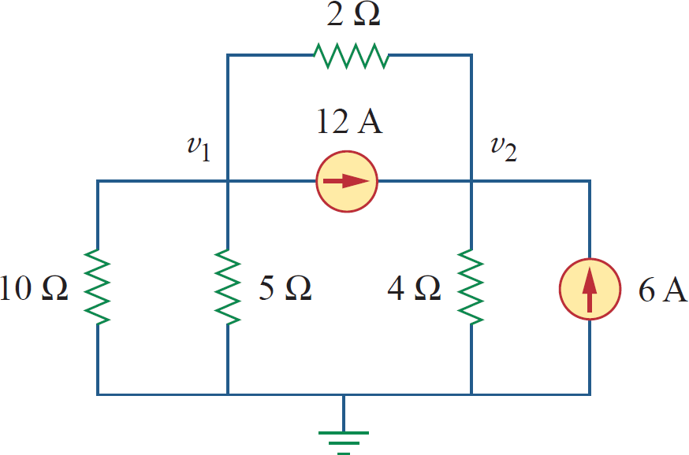

Applying Nodal Analysis:

Applying KCL at node- V1, we get

0.8V1 – 0.5V2 = -12

Appling KCL at node – V2, we get

-0.5V1 + 0.75V2 = 18

Solving Eq1  Eq2 we get

0.5 [0.8V1 – 0.5V2 = -12] -> 0.4V1 – 0.25V2 = -6

0.8 [-0.5V1 + 0.75V2 = 18] -> -0.4V1 + 0.6V2 = 14.4

V1 = 0V V2 =24V